**CONSUMER BEHAVIOUR**

**Executive Summary**

This report provides a detailed analysis of the sustainability practices of Delhi Haat. It has focused on promoting its local economies through Khadi products. The findings include the development of small-scale enterprises in the rural regions, fair trade promotion, and the generation of employment for local artisans. The sale of eco-friendly goods has helped to grow the local economy with direct sales and incentives from the government's policy. Challenges to the Khadi industry include fluctuations in its demands, limited online presence, and competition from modern brands. The recommendations could include more visitor education on sustainability practices through workshops and interactive exhibits to feature eco-friendly products. The certifications of khadi vendors, and an increased promotion of eco-friendly products, and the implementation of effective strategies for waste reduction would help support long-term sustainability.

**Table of contents**

1. Introduction 4

2. Delhi Haat: An Overview 4

3. Sustainability Practices at Delhi Haat 6

● 3.1 Environmental Sustainability 6

● 3.2 Social Sustainability 10

● 3.3 Economic Sustainability 14

4. Evaluation of Sustainability Practices 17

● 4.1 Strengths 17

● 4.2 Challenges 19

● 4.3 Recommendations 21

5. Conclusion 23

References 24

Appendix 27

# 1. Introduction

Delhi haat is a distinct and open-air market that functions as a vibrant hub for the cultures that reside in Delhi. This haat showcases the rich array of various crafts, traditions and unique cuisines of India. This haat was established in the year 1994 and has become an important platform for craftspeople and artisans that provides unique handicraft items and other traditional things (delhitourism.gov.in., 2024). This haat provides a place to sell their handmade products while at the same time promoting Indian heritage and culture among the individuals residing in India and foreign too. The market operates through various stalls that showcase numerous goods such as organic food, khadi clothes and handlooms (Anand and Sekhri, 2022). The purpose of this study is to navigate the sustainable initiatives that are promoted at Delhi Haat which aligns with the increasing demands of the consumer, specifically Khadi clothes. Since consumers are now environmentally conscious along socially responsible, the local stalls of Delhi haat experienced both opportunities and difficulties in fulfilling these needs. Nowadays, sustainability in domestic markets is not only a trend but also a significant component that impacts the reality and longevity of such markets. Therefore, incorporating sustainable practices into the operations of the market vendors can not only captivate eco-friendly customers but also provide social equity and environmental preservation. Therefore, this report aims to evaluate the present sustainability campaigns and initiatives at Delhi Haat to recognise areas for alleviation and bestow actionable recommendations for the vendors to enhance their deliverables according to the preferences of the consumers for suitable products.

# 2. Delhi Haat: An Overview

**● History and establishment**

Delhi haat which was inaugurated in the year 1994 was accepted in the need for a requirement of market marketplace that could collaborate artisans, vendors and craftspersons from different places of India to showcase and sell their unique offerings to the marketplace (Mohan,2024). This idea is to establish a marketplace where the domestic vendors and artisans can sell their products directly to the customers thereby bypassing the middle persons which will help them gain fair prices for their unique products (Das, 2024). Delhi Haat is located in the building area and it was established by Delhi Tourism and Transportation Development Corporation. This was a part of the larger initiative to facilitate and preserve India’s cultural heritage among its masses. The establishment of the market was aimed at exchanging cultural heritage and promoting local crafts among various communities. This distinct concept permitted visitors to face the rich cultural diversity in a single place. Thai Place will showcase an array of products starting from textiles to pottery handlooms and jewellery specifically khadi clothings. During these years the haat has become a renowned destination for both tourists as well as locals attracting many visitors on a yearly basis.

**● Role in promoting Indian culture and heritage**

The role Delhi Haat serves in promoting Indian heritage and culture is by providing craftsmen from various states of India the chance to show their skills and crafts. Each stall in the Delhi Haat shows a distinct place that permits visitors of various states to explore the skills and crafts of that particular place without traveling to that place. Thai fosters a sense of participation among the visitors to know and engage themselves regarding numerous cultural heritages that persist in India. This supports the regional craftsman and also raises awareness about the numerous cultural practices that are within India. Thai market also holds daily cultural; functions involving craft demonstrations, folk performances along food festivals which alleviates the experience of the visitors. Therefore, incorporating these cultural functions the Delhi haat offers a greater amount of appreciation for Indian art and culture. This function not only entertains the visitors but also provides a platform for talented artisans to showcase their skills in a wider area engage with the audiences and share their talent. Additionally, Delhi haat plays a significant function in preserving the traditional skills that may have faded if this platform, was not provided to the regional artisans. Therefore, promoting these crafts and supporting these skilled artisans Delhi haat contributed to the sustainability of the cultural practices and aid in maintaining the rich heritage of India.

**● Description of the market layout and operations**

“DILLI HAAT is located in one of the most important commercial centres of South Delhi, opposite INA market” (delhitourism.gov.in., 2024). The Delhi haat possesses an open-air layout that is farmed to provide an immersive as well as relaxed shopping experience to its visitors. “Dilli Haat boasts 166 stalls of artisans from across 28 states, 29 food stalls from 24 states, and is a part of all “must visit” lists (Das, 2024).” These stalls are thoughtfully arranged which encourages the visitors to explore the diverse offerings. “The complex is set up in the area of 7.2 acres (Delhi.gov.in., 2024).”The stalls are well decorated and represent the skills of the people which invites the attention of the visitors. The market operates as a unique rotating system where the artisans are provided with a distinct time to show their crafts. This makes sure that a wider variety of products are available which permits the visitors to discover different offerings.

# 3. Sustainability Practices at Delhi Haat

## ● 3.1 Environmental Sustainability

**o Use of eco-friendly materials**

The Delhi Haat displays a variety of eco-friendly products that have been curated from natural raw materials. One such distinct product is the 'Khadi clothing'. It is an eco-friendly garment that embodies the rich Indian culture while contributing to environmental protection. Moreover, 'khadi' is a symbol of the freedom struggle in India, thereby adding to the uniqueness of this product (Singh, 2020). The choice of natural fibres such as cotton to manufacture khadi, using a 'chakra' has been essential in sustaining both the authenticity and the surroundings. Besides, other raw materials such as hemp, silk, jute or wool that are grown without the application of pesticides can also be used to manufacture khadi since it leaves a low carbon footprint (Thakker and Sun, 2021).

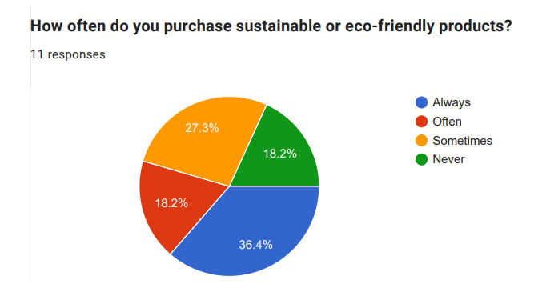

**Figure 1: Purchasing of sustainable or eco-friendly products**

(Source: Survey)

The above Figure 1 shows a pie chart reflecting the frequency of market vendors buying eco-friendly products. The chart has been evaluated through the conduction of interviews with vendors of the local markets to assess the practices of sustainability in Delhi Haat. There were a total of 11 responses collected that were divided into four fractions. The four sections are separated using four different- green, orange, red, and blue that indicate the four different responses- never, sometimes, often, and always respectively. The blue shows the percentage i.e., 36.4%, followed by orange with 27.3%, red and green with 18.2% each. The report shows high efforts made by the vendors to improve sustainability practices through frequent purchases.

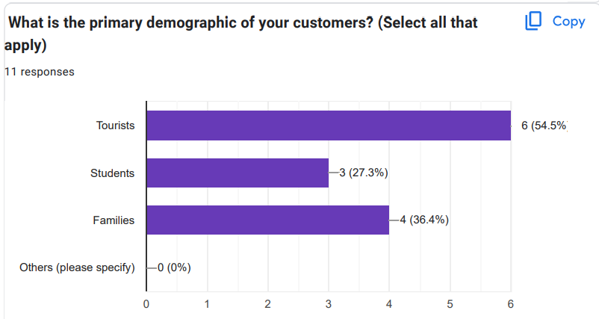

**Figure 2: Primary demographic of customers**

(Source: Survey)

The above Figure 2 shows a graph representing the 11 responses of the vendors regarding the primary buyers of eco-friendly products. The demography is divided into four categories i.e., the tourists, students, family and others. The population consisting of tourists show the highest rate of purchase which is 54.5%, followed by families with a rate of 36.4%, and students at last with 27.3%. This report shows a greater inclination of the foreigners towards buying eco-friendly products.

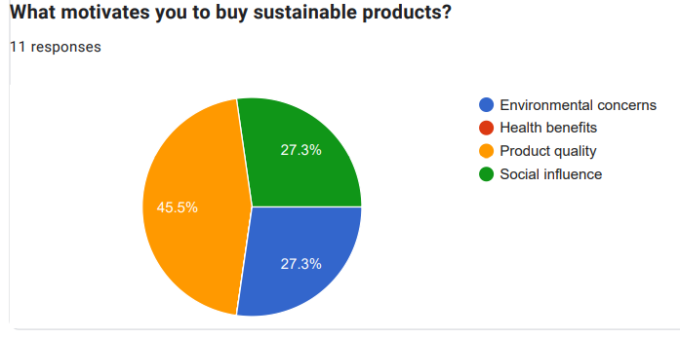

**Figure 3: Motivation for buying sustainable products**

(Source: Survey)

Figure 3 shows a pie chart reflecting the motivation of consumers towards buying eco-friendly products to promote sustainability. This report was evaluated through the conduction of interviews and surveys on the buyers to understand their purchase pattern and behaviour. The interviews were conducted to understand all their aspects of buying which includes their purchase habits, and their awareness and values regarding sustainability. The consumers were chosen from a variety of demographics including gender, age, educational background, and level of income irrespective of being locals or foreigners. The chart is divided into three segments representing the three concerns i.e., environmental, social, and the quality of the products. The product quality was a major motivator with a rate of 45.5%. The influence of other people and environmental concerns accounted for 27.3% each. The chart reflects the motivation and drive of consumers to opt for sustainable products.

**o Waste management and recycling**

Along with the use of sustainable products like khadi clothing, it is very essential to manage waste and promote recycling to safeguard the environment. Since khadi clothing is durable and reusable, it has helped in reducing the waste caused by fabrics. Delhi Haat has adopted a "5 R'sWaste Management" strategy to reduce the amount of waste (Somani *et al.,* 2021). Following this strategy, everyone must adopt the principle of "refuse, reduce, reuse, repurpose, and recycle". Its agenda is to refuse the use of non-biodegradable products to reduce waste. It also focuses on reusing products even if it is not for the same purpose and finally recycling as it decreases waste pollution.

**o Water conservation efforts**

Khadi clothing has contributed to conserving water as a metre of its fabric consumes only three litres of water during manufacture. Besides, the Delhi Haat has also started an online campaign of "be water-wise" as an effort to wisely use the available water resources to prevent its depletion ( Kukreti, 2022). Following this campaign, the people had to pledge to not waste water but instead, reuse and recycle the purified water from R.O. This initiative was necessary to spread the message of conserving water.

**o Energy efficiency initiatives**

Since khadi is made by hand spinning the chakra, instead of big machinery, it is beneficial in reducing the carbon footprint that leads to environmental degradation (Chathukulam and Joseph, 2023). It is manufactured using renewable raw materials and very little electricity, which helps in reducing the emission of greenhouse gases, unlike the other synthetic fabrics. The entire process of making khadi, from the use of natural raw materials to weaving cloth, involves the sustainability of environmental resources. This reflects a low utilisation and proper management of energy resources while manufacturing khadi clothing. Moreover, a very small amount of raw material is wasted as only 10% of cotton is wasted from a kilogram to produce 1000 yarns of thread ([www.sciencedirect.com](http://www.sciencedirect.com/), 2022).

## ● 3.2 Social Sustainability

**o Support for artisans and craftspeople**

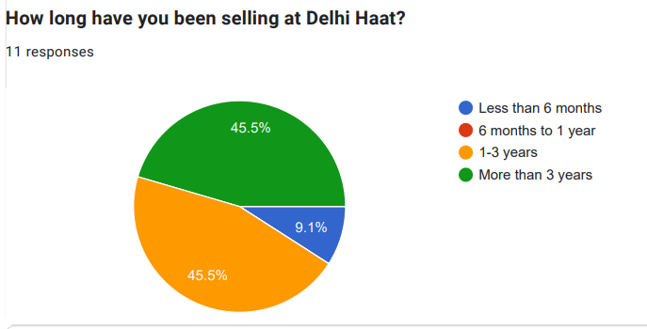

**Figure 4: Time of seeling products at Delhi Haat**

(Source: Survey)

The above graph shows the report of the period of shoppers. It represents the time from when the shopkeepers were selling their products in Delhi Haat. This survey represents the responses of 11 people or shopkeepers who are selling their products in Delhi Haat. The blue color represents that the shopkeepers are selling their products in less than 6 months. The red color represents the time duration of the shopkeeper which is between 6 months to 1 year. On the other hand, the orange color represents the time duration which is between 1 to 3 years and the green color shows more than 3 years. Here, the graph shows the result that 45.5% of shopkeepers are selling their products in between 1 to 3 years. On the other hand, the green colour shows that 45.5% of shopkeepers have been selling their products for more than 3 years. Whereas, the blue colour represents that 9.1% of people are selling their products in less than 6 months. The results and observations from the conducted survey show that the shopkeepers support the artisans and craftspeople (Anand and Sekhri, 2022).

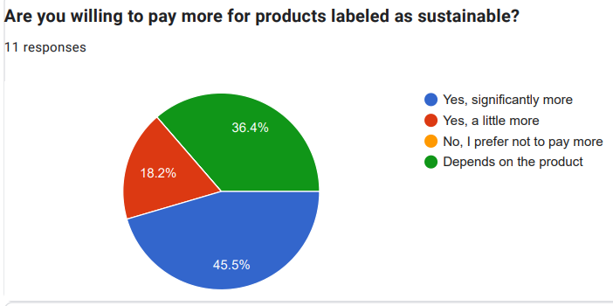  
**Figure 5: Purchasing of sustainable or eco-friendly products**

(Source: Survey)

From the above graph, it has been observed that consumer behaviour is related to sustainable consumption in the community market. This graph represents the behaviour of the consumers related to sustainable consumption that people are willing to pay more for products which are labelled as sustainable or not. The survey was conducted between the shoppers in which 11 shoppers have responded. These responses vary from person to person, they have different perspectives and different opinions (Okada, 2022). This graph shows significant results of the survey where each color has a different meaning which is based on the opinions of 11 shoppers. The blue colour represents the opinion of those shoppers who are willing to pay significantly more for the products labelled as sustainable. The red colour represents the opinion of those shoppers who are willing to pay a little more for the products whereas the orange color represents the opinion of those shoppers who are not willing to pay more for the products which are labelled as sustainable. On the other hand, The green colour represents the opinion of those shoppers who said that it will depend on the product that they will pay more or not for it. After the survey, this graph has been created based on their opinions. This graph shows that 45.6% of shoppers are willing to pay more for those particular products which are labelled as sustainable and they will help in sustainable consumption. On the other hand, 18.2% of shoppers have said that they will pay a little more for those particular products. But at the same time, it has been observed that 36.4% of people will think to pay more after reviewing the product. According to them, their extra payment would be dependent on the product. It shows that consumers are interested in supporting the artisans and craftspeople. From the above graph, the buying habits of the consumers have been observed along with their attitudes towards sustainability due to which they are willing to pay more for the products and interested in supporting local communities.

**o Cultural preservation efforts**

According to the researcher, Gill, *et al*. (2023) cultural preservation is a crucial part of sustainable development and there are several efforts which help preserve the cultural heritages and also promote sustainable consumption (Gill, et al. 2023). Khadi is one of the main heritage of Indian culture which is used by many people now also. Khadi helps in providing a source of livelihood to the rural people which results in preserving India's rich cultural heritage. For preserving these cultures it is required to take several steps such as inventory, funding, policies and many more including WHO.

**o Community engagement and awareness programs**

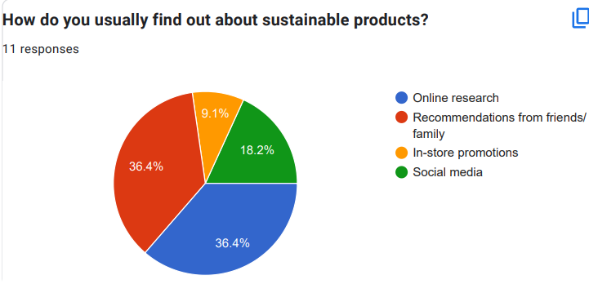  
**Figure 6: Medium for finding sustainable products**

(Source: Survey)

According to the researcher, Yadav and Modi. (2022), community engagement and strategies are a kind of strategy which includes working with the communities to acknowledge and address the issues (Yadav and Modi. 2022). This graph is based on community engagement and awareness programs. The graph shows how consumers usually find sustainable products. The result of the survey shows different opinions which have been represented in several colors here. The blue colour shows that 36.4% of shoppers find their products with the help of online research whereas the red colour shows that 36.4% shoppers buy their products based on the recommendation of friends and family. Orange colour represents that 9.1% of shoppers buy their products through store promotions on the other hand green colour shows that 18.2% of people buy their products with the help of social media.

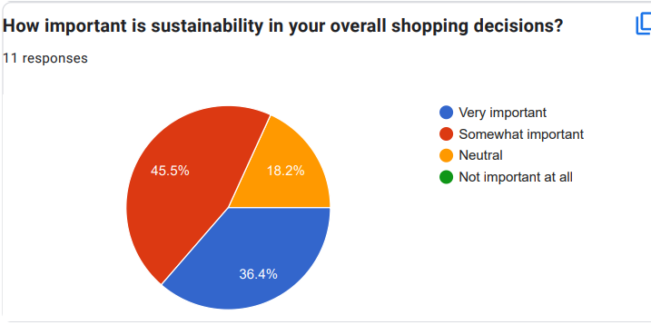

**Figure 7: Important of sustainability for shopping decisions**

(Source: Survey)

According to the results of the survey, sustainability is very important in overall shopping. After conducting the survey, 36.4% of people said that sustainability is very important in overall shopping. 45.5% of people said that it is somewhat important whereas 18.2% of people said that the importance of sustainability in overall shopping is neutral. Hence, the graph shows the importance of community engagement and awareness programmes.

## ● 3.3 Economic Sustainability

**o Promotion of the local markets**

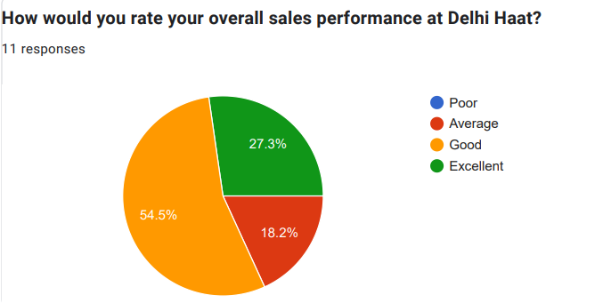

**Figure 8: Rating of overall sales performance at Delhi Haat**

(Source: Survey)

Delhi Haat promotes the local economy by encouraging the local trade markets to exhibit and sell their goods at the market. The selling of indigenous goods like Khadi boosts the economy of the small-scale local markets. The market displays a wide range of products manufactured by local sellers. This allows the visitors to buy these local products instead of those manufactured in other cities and towns. Representation of locally manufactured goods at Delhi Haat fosters improved performance of these small-scale enterprises. As the local businesses feel obliged to satisfy a large customer base, they attempt to enhance their performance. According to a majority of Delhi Haat’s sellers, their sales performance is “good”. The buyers have also reported a positive shopping experience at the market. This indicates that Delhi Haat has been successful in promoting the local economy through a satisfactory selling approach. The market has contributed to the people’s increased interest in buying eco-friendly Khadi clothes. The micro and small rural enterprises, particularly those from the rural Khadi industries, are greatly benefitted by this market’s sales promotions (Alaguraja and Nedumaran, 2020).

**o Practices**

An important practice employed by Delhi Haat to promote a sustainable economy is the encouragement of eco-friendly indigenous products like Khadi clothes. By enabling the sale of environment-friendly goods from the local markets, Delhi Haat increases its overall economic growth. This also fosters the improvement of the local trade markets. The interviewing of the sellers at Delhi Haat helps to gain useful insights into their sustainability practices. When the sellers were asked to rate their overall sales performance, 54% of the sellers provided a positive response. They have identified their performance as “good”, implying a satisfied sales experience. On the other hand, when the buyers were asked to state the importance of sustainability in their shopping decisions, a major section of them reported that sustainability was “somewhat important” in their shopping decisions. 36.4% of shoppers stated that it is very important to them. The remarkable popularity of Delhi Haat implies that the sales market has been successful in fulfilling the sustainability demands of its customers by selling eco-friendly goods, like Khadi clothes. This market provides a favorable platform to the artisans and manufacturers of rural Khadi enterprises, thereby promoting the local economy with considerable success (Tanwani and Maisuria, 2020)

**o Employment generation**

By providing a favorable platform to the Khadi traders for carrying out their businesses, Delhi Haat plays an active role in employment generation. The market enhances the employment of a large number of workers. Due to the promotion and support offered by Delhi haat, the local markets experience an increased demand for goods. This results in the requirement of more workers to carry out the operations of the businesses. This leads to an increase in employment opportunities for craftsmen, weavers, artisans, and other skilled individuals. The manufacturing of Khadi clothes requires the collaborative efforts of large groups of individuals (Thomas, 2020). Hence, the local Khadi enterprises need to employ a large number of workers to meet the demands of a substantial sales market like Delhi Haat. By generating employment, Delhi Haat significantly contributes to the economic stability in the Khadi industry.

# 4. Evaluation of Sustainability Practices

## ● 4.1 Strengths

**o Cultural and social impact**

The sustainability practices of Delhi have a positive impact on the culture and society as it has preserved traditional crafts such as handloom weaves, patterns, and many more. It is involved in stimulating local markets or haats by furnishing them with a selling platform. It includes a variety of handmade items to safeguard traditional crafts. It has also brought modern innovations, creativity, and resilience to societies. Therefore, it has contributed to long-term sustainable development as it guarantees inclusive and balanced progress which is based on the requirement and opinion of every individual and community. It has bestowed strength on the economy by stimulating economic independence, especially for women. It has also concentrated on preserving heritage which is regarded as a symbol of cultural resources. However, it has been identified that several artisans of Delhi-haat use eco-friendly materials and Khadi clothing is one of them. Furthermore, its method of traditional production has been used to minimize environmental issues like soil degradation. Khadi has been considered as the cultural emblem of India. It is because it has a historical association with Mahatma Gandhi along with the movement of Indian independence. Consumer behavior on sustainability practices led to the rise in the modern and traditional values in the culture.

**o Economic benefits**

The sustainability practices of Delhi Haat especially with its Khadi products benefited the economy in various ways. It includes exclusive pricing concerning eco-friendly products as Khadi is considered one of the eco-friendly brands in India. It has also contributed to the economic empowerment of artisans in the rural areas of India. It has been found that economic empowerment is a vital phenomenon that makes women empowered, especially women. Policymakers have benefited from this phenomenon by gaining knowledge about practical methods to curtail poverty and inequalities. Furthermore, it helps in the advancement of sustainable development. It has positively impacted economic growth, the reason is based on the upliftment of the economic entrepreneurs. There has been a remarkable profit among the artisans in Delhi due to their direct sales to the customers. As a result, this direct market availability helped to remove barriers from intermediaries and enabled a growth in the profit margin. Thus contributed to the wider economic growth concerning the Khadi producers (Pathak and Gupta, 2023). However, by stimulating Khadi in the Haat of Delhi, the artisans along with the producers have benefitted from the Delhi Government. These benefits include subsidies, incentives along training programs that again contribute to the economic upliftment.

**o Environmental initiatives**

The Khadi brand generates eco-friendly products which focus on the sustainability of the environment. Green marketing is also known as the promotion of eco-friendly products and services (Alamsyah *et al*., 2020). It involves the alteration of products or services, and enhancement in the process of manufacturing along with boosting promotion. In the contemporary era, Khadi products are offering a sustainable manifestation that promotes sustainable economic activity. The relationship between customer consumption and marketing practices is significant in enhancing the performance of the business of the Khadi textile industry. Furthermore, the industry of Khadi Textile generates green products, which provides a greater understanding of the implications of green marketing practices which have boosted the environment. There have been noticeable changes in the environment due to the ‘low carbon carbon footprints’ (Valovuori-Kilpi, 2020). This is because Khadi products are generally based on weaving, there is no usage of machines and electricity. Energy consumption has been profoundly reduced due to this traditional method, along with the reduction of carbon footprint as compared to other textile industries. Employing Khadi products, Delhi Haat has encouraged low-impact production methods in the process of a sustainable environment.

**Visitor awareness and engagement**

Visitors' awareness and engagement provide scarcity in knowledge and sustainability due to the unawareness of several visitors about the environment, along with the social advantages of Khadi products (Deb, 2023). It has the tendency to view this textile just like other textile industries in the world. They may not be a draw of the eco-friendly nature of the textile industry like its efficacy of reducing carbon footprints and its benefits to rural places or livelihoods. Therefore educational efforts are needed to raise awareness of the local people and people from other communities.

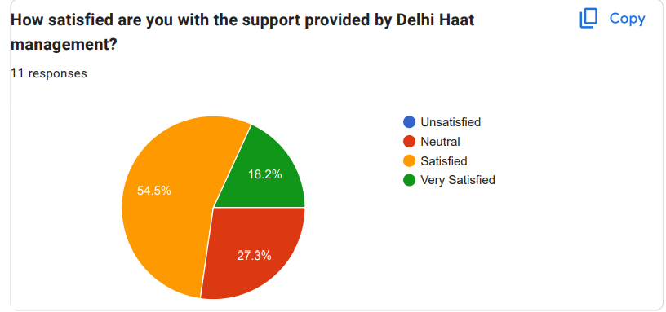

**Figure 9: Satisfaction regarding the support provided by Delhi Haat**

(Source: Survey)

## ● 4.2 Challenges

**o Scalability of practices**

Khadi clothing has been facing challenges due to changing times and the emergence of new and more trendy clothes. The changing preferences of clothing have fluctuated the demands for khadi clothing (Pathak. and Mukherjee, 2021). Moreover, the invention of new machinery that helps in fastening the production and delivery processes has been replacing authentic khadi since its production process is gradual. Moreover, the wide availability of identical khadi clothes at cheaper prices has led to a decrease in the demand for original khadi. The production of khadi is labour-intensive but the development of technology in contemporary times has led to a shortage of employees.

**Visitor awareness and engagement**

There are several challenges which Khadi clothing is facing with the time changes and also preferences of the people. Nowadays people generally prefer khadi clothes less and they always want to go with the trend and follow today's fashion with modern culture. Whereas khadi represents our heritage culture. The challenges of khadi clothing related to visitors' engagement and awareness are as follows:

* Limited brand awareness- Khadi represents the culture of the old generation and relates to traditions. Nowadays many young people do not prefer these old traditions and want to go with the modern trend (Saad, 2021).
* Limited online presence- Many Khadi products are outlets that do not have any presence on online sites. Without digital presence, it is harder and also a challenge for Khadi clothes to reach the younger generation nowadays where they are disconnecting without traditions.
* Availability and inconsistent quality of the products- As Khadi is a hand-made product so the quality of the product varies sometimes. Hence, it depends on the preference of the people who like it or not. The availability of the products is not consistent also which sometimes disappoint visitors.
* Perceived and expensive- Khadi products are handmade products which are always considered premium products in terms of clothing. It is sometimes hesitant and uncomfortable for visitors due to the cost if they have affordable options only (Schnell, 2022).
* Competition with other brands- In today's modern generation there is a tough competition of fashion and mass products which is a great challenge for Khadi clothes. Khadi promotes “sustainability and handmade craftsmanship.”

**o Visitor awareness and engagement**

Visitors' awareness and engagement provide scarcity in knowledge and sustainability due to the unawareness of several visitors about the environment, along with the social advantages of Khadi products. It has the tendency to view this textile just like other textile industries in the world. They may not be a draw of the eco-friendly nature of the textile industry like its efficacy of reducing carbon-footprints and its benefits to rural places or livelihoods. Therefore educational efforts needed to raise awareness of the local people and people from other communities.

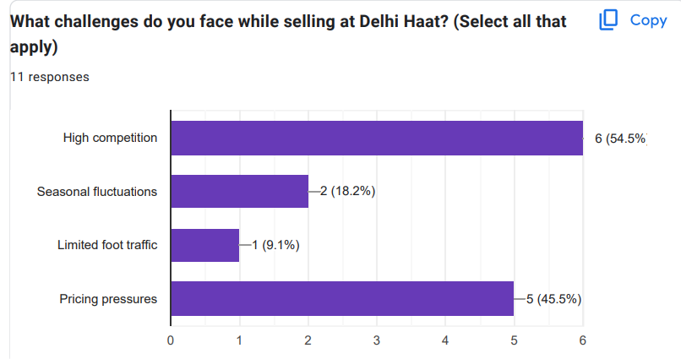

**Figure 10: Challenges faced during selling at Delhi Haat**

(Source: Survey)

**o Economic viability during downturns**

Economic downturns significantly impact the economic progress of a business. Downturn refers to a considerable reduction in the sales capacity of a business (Hofmann, *et al.* 2022). It can be caused due to a variety of reasons. In the case of a substantial sales market in Delhi Haat, downturns cause considerable effects. During downturns, the financial growth of the market is adversely affected due to reduced business transactions. Although Delhi Haat ensures steady cash inflow throughout the year, downturns cause a considerable decline in its economic performance.

## ● 4.3 Recommendations

**o Enhancing visitor education on sustainability**

In order to encourage a detailed and deeper understanding and recognition of sustainability among visitors it is important for Delhi Haat to execute an educational program that significantly highlights the increasing necessity of “eco-friendly” practices and products. This includes regular workshops that successfully teach the visitors about practices that are highly sustainable. This consists of the advantages of using Khadi and other materials which are “eco-friendly”. Further live presentation by artisans which proactively showcases the process of crafting can also work towards raising the awareness of the efforts and skills which are popularly associated with creating products that are sustainable. An interactive exhibit that highly emphasises sustainability can positively work to engage the visitors in a dynamic manner. This could involve experiences of virtual reality and displays which popularly showcase the lifecycle of the outcomes by specifically focusing attention on the “eco-friendly” materials and their advantages to the environment. The development of digital and printed guides which work in guiding sustainable practices of shopping thereby providing tips for the reduction of waste is necessary (Bolwig *et al*., 2021). Executing mechanisms of fair pricing guarantees that the artisans receive the wage which is deserved for their products. This can work in increasing the livelihoods towards maintaining sustainable practices in an integrated manner.

**o Expanding eco-friendly initiatives**

In terms of expanding “eco-friendly” initiatives, it is necessary to encourage vendors to primarily source their Khadi from cooperatives and certified weavers which necessarily adheres to the practices that are sustainable. This will not only work in terms of giving support to the local artisans but it also guarantees the environmental integrity and authenticity of the products in an integrated manner. Further by effectively establishing a program of certification which is specifically based on khadi vendors which proactively meets the criteria of sustainability. This certification will prominently help the consumers recognize genuine “eco-friendly” products that are based on Khadi. This aspect will play a vital role in terms of boosting their confidence towards making purchases that are sustainable. Further, the implementation of educational campaigns on the advantages of Khadi can also proactively help towards gaining standard growth and productivity in an integrated manner. By effectively launching initiatives which successfully highlight the social and environmental advantages of Khadi thereby focusing attention on its increasing role towards sustainable fashion (Saad, 2021). By using demonstrations and workshops to showcase the “eco-friendliness” and craftsmanship of Khadi can play a vital role in captivating more visitors. It is also important to provide incentives for the vendors of khaadi to adopt practices that are sustainable. This includes executing strategies of waste reduction and biodegradable packaging in their stalls can help in gaining standard productivity.

**o Replicating successful practices in other markets**

In terms of replicating successful practices in other markets, it is extremely important to adopt programs of “eco-certification”. Other markets can execute similar programs based on “eco-certification” for the vendors which guarantees that only sustainable products are sold in the market (Nguyen Khanh, 2020). This aspect plays a vital role in promoting ethical sourcing and building trust of consumers. This also includes training vendors on the production of Khadi by organising seminars and workshops which are proactively focused on sustainable techniques of Khadi production. This workshop needs to focus attention on executing “eco-friendly” practices and traditional methods. Events based on community engagement around Khadi which includes demonstrations of craft and fashion shows can play a prominent role in increasing appreciation and awareness for its cultural significance in an integrated manner. The effective engagement of the community can encourage a supportive environment for the artisans of Khadi.

# 5. Conclusion

On overall analysis, it is observed that Delhi Haat has successfully positioned itself as a hub which is extremely vibrant towards effectively showcasing in promoting sustainability and Indian culture specifically through its focus on the products of Khadi. The overall findings mainly indicate that the market prominently supports the artisans in an effective manner thereby providing a suitable platform for encouraging awareness on the practices that are sustainable.

On analysing the overall assessment of the sustainability practices of Delhi Haat it is observed that it has made a notable impact not only on the consumers and local artisans but also on the wide narrative of the commencement in India which is sustainable. The approach of the market suitably serves a model that is valuable for the other local markets that are seeking to increase their efforts of sustainability.

The potential impact on other local markets includes enhanced consumer awareness of the products which are “eco-friendly” and increased support for the local artisans. This also includes maintaining a stronger commitment towards sustainable validation. By effectively promoting initiatives based on community engagement and promoting cultural heritage other local markets can drive demand for the goods that are produced ethically thereby encouraging a more vibrant and sustainable marketplace.

# References

Alaguraja, M. and Nedumaran, D.G., 2020. Performance of khadi and village industries commission through micro, small, & medium enterprise. *Aegaeum Journal*, *8*(3).

Anand, A. and Sekhri, S., 2022. Indian Handlooms: Present Scenario and Future Directions.

Anand, A. and Sekhri, S., 2022. Indian Handlooms: Present Scenario and Future Directions.

Bolwig, S., Tanner, A.N., Riemann, P., Redlingshöfer, B. and Zhang, Y., 2021. Reducing consumer food waste using green and digital technologies.

Chathukulam, J. and Joseph, M., 2023. Making of a Climate Smart Village: A Study on Meenangadi Gram Panchayat in Kerala (India). In The Palgrave Handbook of Socio-ecological Resilience in the Face of Climate Change: Contexts from a Developing Country (pp. 277-298). Singapore: Springer Nature Singapore.

Das, A. (2024). *Dilli Haat, a centrepiece of Delhi, turns 30*. [online] Hindustan Times. Available at:<https://www.hindustantimes.com/cities/others/dilli-haat-a-centrepiece-of-delhi-turns-30-101711304117275.html> [Accessed 3 Oct. 2024].

Deb, S., 2023. Revival of Khadi Industry in Assam: Adversities and Challenges-A Study. *Journal of Global Economy*, *19*(1).

Delhi.gov.in. (2024). *Dilli Haat Pitampura | District North West, Government of Delhi* | India. [online] Available at: <https://dmnorthwest.delhi.gov.in/tourist-place/dilli-haat-pitampura/> [Accessed 3 Oct. 2024].

delhitourism.gov.in. (2024). :: *Dilli Haat INA* :: [online] Available at: <https://delhitourism.gov.in/delhitourism/tourist_place/dilli_haat_INA.jsp> [Accessed 3 Oct. 2024].

Gill, P., Malik, P., Arya, N. and Yadav, N., 2023. Khadi: A proud choice of Indian youth.

Hofmann, E., Töyli, J. and Solakivi, T., 2022. Working capital behavior of firms during an economic downturn: an analysis of the financial crisis era. *International Journal of Financial Studies*, *10*(3), p.55.

Kukreti, A. (2022) Take the be water wise pledge this world water day, Delhi Greens Blog. Available at: <https://delhigreens.com/2011/03/22/take-the-be-water-wise-pledge-this-world-water-day/> (Accessed: 03 October 2024).

Mohan, A. (2024). *Delhi’s iconic Dilli Haat: Churn from traditional to run-of-the-mill*. [online] Fortuneindia.com. Available at: <https://www.fortuneindia.com/macro/delhis-iconic-dilli-haat-churn-from-traditional-to-run-of-the-mill/117541> [Accessed 3 Oct. 2024].

Nautiyal, V.T. and Atre, A., 2020. A Study on Evolution of Khadi and Current Factors Leading to Potential Opportunities in Khadi Sector. *Fashion & Textile Industry 4.0-Opportunities & Challenges for Education 4.0*, p.69.

Nguyen Khanh, L., 2020. The effects of green digital marketing towards finnish consumers’ environmental awareness and company’s sustainability.

Okada, Y., 2022. Transformation of Gandhi’s Khadi: From a. History and Theory, 4, pp.80-88.

Pathak, N.P. and Gupta, S., 2023. Performance of Khadi and Villege Industries in India. *International Journal of Advances in Social Sciences*, *11*(1), pp.9-13.

Pathak, S. and Mukherjee, S., 2021. Entrepreneurial ecosystem and social entrepreneurship: case studies of community-based craft from Kutch, India. Journal of Enterprising Communities: People and Places in the Global Economy, 15(3), pp.350-374.

Saad, S., 2021. Culture and Handicraft Tourism in India: Tourism supporting sustainable development goals.

Saad, S., 2021. Culture and Handicraft Tourism in India: Tourism supporting sustainable development goals.

Schnell, M., 2022. Khadi and the politics of viability and care: an exploration of handloom institutions in Karnataka (Doctoral dissertation).

Singh, R., 2020. MAHATMA GANDHI AND KHADI: AN ANALYTICAL STUDY. *INDIAN JOURNAL OF SOCIAL SCIENCES & SOCIETIES*, p.15.

Somani, P., Navaneethan, R.D. and Thangaiyan, S., 2021, May. Integrated solid waste management in urban India: A mini review. In Journal of Physics: Conference Series (Vol. 1913, No. 1, p. 012084). IOP Publishing.

Tanwani, R.M. and Maisuria, M.H., 2020. Performance Of Khadi And Village Industries (Kvi) Of MSME Sector. *Grand Academic Portal Interdisciplinarities*, *3*(4), pp.258-262.

Thakker, A.M. and Sun, D., 2021. Sustainable plant-based bioactive materials for functional printed textiles. The Journal of the Textile Institute, 112(8), pp.1324-1358.

Thomas, J., 2020, TEXTILE TOURISM: OPPORTUNITIES AND CHALLENGES FOR KHADI INDUSTRIES. *ASIAN TOURISM RESEARCH*, p.314.

Valovuori-Kilpi, K., 2020. Improving environmental sustainability in the use phase of the product life cycle: Case Reima Oy.

[www.sciencedirect.com](http://www.sciencedirect.com) (2022) Unusable cotton spinning mill waste: A viable source of raw material in paper making, Heliyon. Available at: <https://www.sciencedirect.com/science/article/pii/S2405844022013433> (Accessed: 03 October 2024).

Yadav, D. and Modi, S.K., 2022. Khadi Consumer Awareness in Delhi/NCR Region: Exploring Influencing Factors. Journal of Positive School Psychology, 6(3), pp.9262-9270.

# Appendix

